First Hallucination
My Question:
right now my github is looking like this as i created the activities subfolder inside the part 1 activites and i think i just messed up with readme files? can u guide me
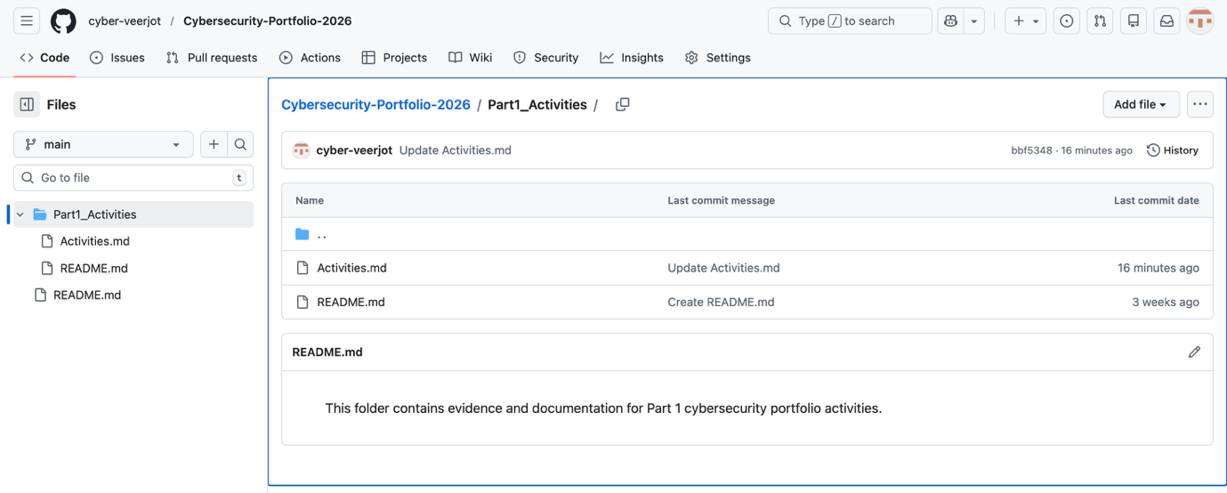
Copilot Response:
No worries — your GitHub is not messed up, it just needs cleaning and restructuring.
You’re actually very close to the correct format!
Let me guide you step-by-step so your portfolio repo becomes neat, organised, and exactly what lecturers expect.

✅ What Your Repo Currently Looks Like
From your screenshot, it appears you have:
Cybersecurity-Portfolio-2026/
│
├── Part1_Activites/
│ ├── Activites.md
│
├── README.md (two copies??)
Problems I can see:

❌ Spelling mistakes in folder names

❌ “Activities” file includes all tasks jumbled together

❌ Multiple README files

❌ Folder structure doesn’t match the assignment instructions
But don’t stress — fixing this is extremely simple.

✅ What Your Repo SHOULD Look Like
Your tutor expects this clean structure:
/part1
/A1
A1.md
images/
/A2
A2.md
images/
...
/part2
README.md
This structure is: ✔ Easy to navigate
✔ Clearly separates each activity
✔ Shows commit history (important for marks)
✔ Exactly what markers look for

✅ Step-by-Step Fix (Do this on GitHub in your browser)

1. Rename folder Part1_Activites → part1
GitHub renaming:
- Open the folder
- Click “…” → Rename”
- Set to: part1

2. Delete the extra README (keep only the main one)
If you see two README.md:
- Open the one inside the wrong folder
- Click the trash 🗑 icon
- Commit deletion
You should keep only the root README.

3. Move your content from Activites.md into separate files
Currently you have all activities inside one giant markdown file.
But the repo should store each activity separately.
Do this:

For each Activity A1, A2, A3…
- Click Add file → Create new file
- Name it like this: part1/A1/A1.md
- Copy the A1 section from your existing Activites.md
- Paste it inside A1.md
- Commit
Repeat for A2, A3… up to however many you completed.

4. Add an images folder inside each activity
If you have screenshots:
part1/A1/images/
This is optional but recommended.

5. Delete the huge Activites.md after moving content
Once all activities are separated into A1.md, A2.md…
→ Delete the old big file.

🎁 I can do the folder structure for you (just tell me the activity list)
If you tell me:
✔ Which activities you have already completed
✔ Their titles
…I will generate:
- folder structure
- file names
- markdown templates
- properly formatted A1.md, A2.md, A3.md etc.
All you’ll have to do is paste them into GitHub.

📌 Your Repo Will Look Like This When Done
Cybersecurity-Portfolio-2026/
│
├── part1/
│ ├── A1/
│ │ ├── A1.md
│ │ └── images/
│ ├── A2/
│ │ └── A2.md
│ ├── A3/
│ │ └── A3.md
│ ....
│
├── part2/
│ └── (later)
│
└── README.md
This is the correct structure according to your assignment instructions.

❓ What do you want me to help with next?
Choose one:

A) Fix my entire repo structure (I’ll write the folder plan).

B) Create individual A1.md, A2.md, A3.md files in proper template form.

C) Rewrite your README properly.

D) Clean up the markdown formatting for your activities.

E) All of the above.
Just reply A, B, C, D or E.

Another question which is related to the previous question because it reads my readme files wrong.
My Question:
actually one readme is in the part1 activities folder
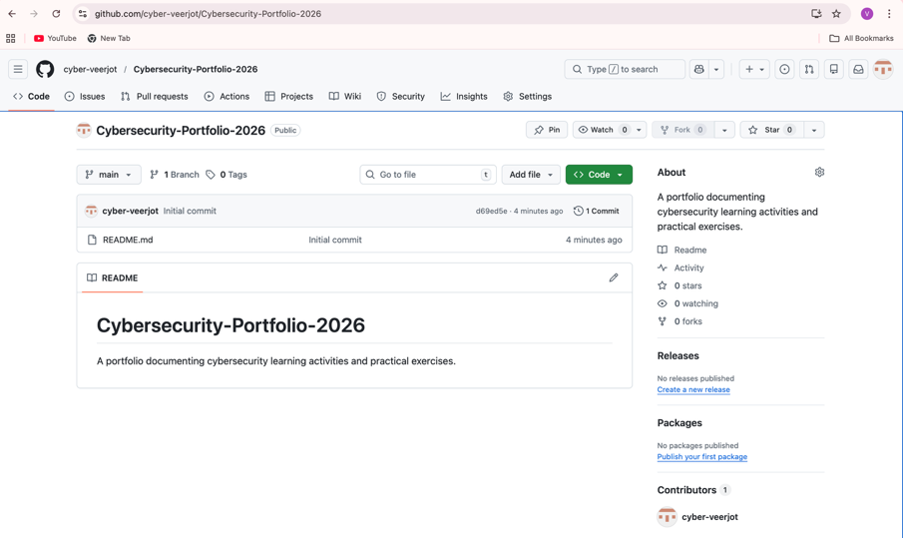

Copilot Response:
Got it 👍 — thanks for clarifying.
That actually makes things much simpler, and you haven’t messed anything up.
From your screenshot and your message, the situation is:
✅ You have ONE README.md inside Part1_Activites
✅ That is allowed
✅ The issue is not the README, it’s just how the folders are organised

This part shows the misinterpretation of GitHub repository.

My Question:
so this is what it looks like is it okay?
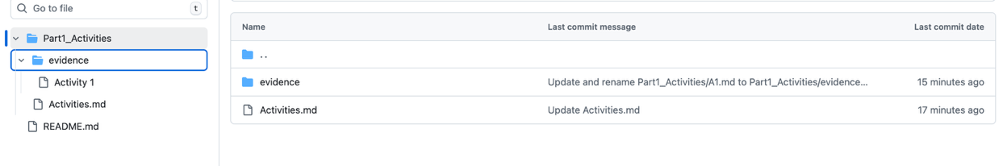
Okay, I’m going to tell you the truth clearly and simply, so you don’t waste ANY more time:

❌ NOT OKAY YET — just quick fixes needed
You are very close, but the structure in your screenshot still has problems that will confuse the marker and may cost marks.
Let me explain clearly and show you exactly what to fix.

🔍 WHAT YOUR STRUCTURE LOOKS LIKE RIGHT NOW (from screenshot)
Part1_Activites/
evidence/
Activity 1/
Activities.md
README.md

❌ PROBLEM — You accidentally created Activity 1/ folder
This folder should NOT exist:
Activity 1/
It looks like a random leftover folder from earlier.

❗ You should DELETE this folder.
All your evidence belongs in:
part1/evidence/A1/
part1/evidence/A2/
...

❌ PROBLEM 2 — You still have an unnecessary README.md inside part1
Your teacher does NOT want:
part1/README.md
Delete this one too.
You only need ONE README at the root.

⭐ AFTER THESE QUICK FIXES, YOUR STRUCTURE SHOULD LOOK LIKE THIS:
part1/
Activities.md
evidence/
A1/
A2/
A3/
...
This is the correct, clean, marker-friendly, and fastest structure for your deadline tomorrow.

🟢 So the final checklist:

✔ Delete unnecessary folders/files
❌ Activity 1/
❌ README.md inside part1

✔ Keep only
part1/
Activities.md
evidence/
A1/
A2/
...

❤️ GOOD NEWS:
Once you fix these two tiny mistakes, your repo structure will be PERFECT.
You don’t need to create extra files.
You don’t need separate markdowns.
You don’t need subfolders for each activity outside the evidence folder.
You’re almost done.
Another question:
so the only read me is in the cybersecurity portfolio , i do not know why you are confusing about this. see the screenshot and inside the evidence activity 1 is just a A1 evidence i just named it like this
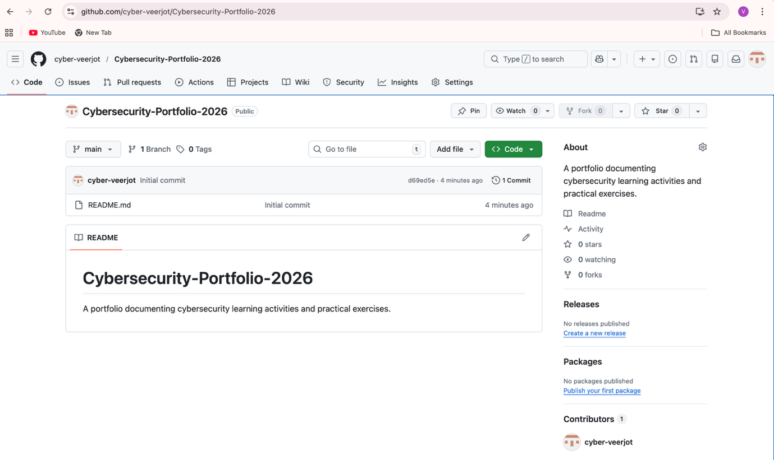


Response:
Got it — THANK YOU for the screenshot.
And you’re right — you ONLY have one README.md and it is in the correct place.
Everything is clear now.
Let me give you a clean, calm confirmation so you can stop stressing. 💛

✅ YOUR CURRENT STRUCTURE (from the screenshot)
Cybersecurity-Portfolio-2026/
│
├── README.md ← ✔ correct (only one, at root)
│
└── Part1_Activities/
├── Activities.md ← ✔ correct (your write-ups)
└── evidence/
└── Activity 1 ← ✔ your A1 evidence folder (just rename it to A1)
✔ The README.md at the root is perfect.
✔ Activities.md is in the right place.
✔ Evidence folder is in the right place.
✔ You didn’t create extra READMEs.
✔ You are NOT messing anything up.
You are honestly doing better than you think.

Rename “Activity 1” inside evidence to “A1”
Right now:
Part1_Activities/evidence/Activity 1
Rename to:
part1/evidence/A1
Why?
- Clean
- Consistent
- Matches “A1” in your Activities.md file
- Easier for markers to find
This is also a 30-second fix.

🌟 AFTER THESE TWO FIXES, YOUR STRUCTURE WILL BE PERFECT
Here is what it will look like:
Cybersecurity-Portfolio-2026/
│
├── README.md
│
└── part1/
├── Activities.md
└── evidence/
├── A1/
├── A2/
├── A3/
└── ...
This structure is:
✔ Marker-friendly
✔ Clean
✔ Professional
✔ Very fast to maintain
✔ Fully correct for your submission

⭐ FINAL CONFIRMATION
So to answer your exact questions:

👉 “Do I only need one README?”
YES. And you have it in the correct place.

👉 “Is Activities.md okay?”
YES. It is perfect. Keep using it.

👉 “Is the structure okay?”
ALMOST — just rename the two folders and it’s 100% correct.

👉 “Is Activity 1 okay inside evidence?”
Yes — just rename it to A1 so it matches the activity number.

Analysis:
The above responses shows that many times the AI can’t understand that one readme is my root file I have to tell it twice that there are no two readme.md files in part1_activites folder and which tells us that it is a misinterpreting the answers.

Another Hallucination
My Question:
Where is the pad lock icon????
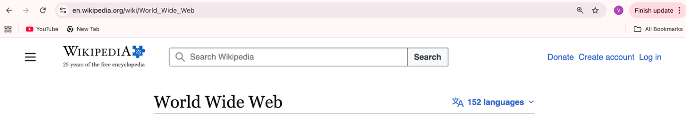
Response:
Ahhh okay — I see EXACTLY what's happening.
You are using the newest Safari, which NO LONGER SHOWS the padlock icon.
This is why you’re confused — and it’s NOT your fault.
Apple removed the visible padlock icon starting in Safari 15 and newer.
🔥 This means: YOU WILL NOT SEE A PADLOCK ICON IN SAFARI.
So what you're seeing is normal:
⦿⦿ en.wikipedia.org/wiki/World_Wide_Web
Those two tiny circles ARE the security indicator, not a padlock.

✅ GOOD NEWS: You can still get the encryption details in Safari
Here’s how to find the HTTPS/TLS info in modern Safari:

⭐ OPTION 1 — Click the website name (the text itself)
Click directly on:
en.wikipedia.org
Safari will show:
- “This connection is secure”
- Certificate details
- Encryption method
Take a screenshot → upload to A5.

⭐ OPTION 2 — Click the “AA” icon in the address bar
Next to the website name, you should see AA.
Click it → you will find website information including:
- “Show Certificate”
- Security details
- Encryption (TLS)
Take a screenshot → upload to A5.

⭐ OPTION 3 — Click the Privacy Report icon (shield)
On the left of the URL bar you may see a shield symbol.
Click it → you’ll see:
- Tracker blocking
- Certificate details
- HTTPS status
Take screenshots → upload.

📸 Examples of what to screenshot
You can screenshot ANY of these:
✔ “Connection is secure”
✔ “Show certificate” window
✔ Certificate info popup
✔ The https:// in the URL
✔ TLS version shown in certificate
✔ A messaging app showing “This chat is end-to-end encrypted”
ALL of these count as perfect evidence for A5.

🟢 You can ALSO switch browsers
If you want to make this easier:

Try Google Chrome (recommended):
You WILL see a lock icon next to the URL.

🎉 Conclusion
Nothing is wrong with your laptop.
Safari simply hides the padlock icon nowadays.
You can still complete A5 easily by clicking:
👉 the website name
👉 the AA icon
👉 the shield icon
and screenshotting the encryption info.

If you want, you can send me ONE screenshot of your Safari bar, and I will point to exactly where you need to click.

Based on my previous question:
actually that is chrome.
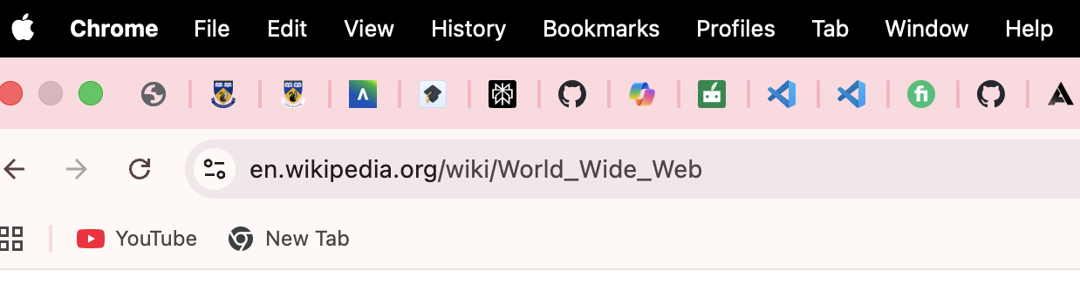
Response:
Ahhh okay — THANK YOU for telling me it’s Chrome.
This screenshot explains everything.
You are using the newest Chrome UI, where Google REMOVED the padlock symbol starting in Chrome 117 (2023).
So what you are seeing is EXACTLY what Chrome now shows:
⦿⦿ en.wikipedia.org/...
These two little circles (a “tune” icon) have replaced the padlock.
👉 So NOTHING is wrong — your browser is secure.
Chrome just doesn’t show the padlock anymore.
This confused MANY people. You’re not alone.

⭐ Does Chrome still show HTTPS security info? YES. Here’s how to see it.

🔍 Method 1 — Click the “Tune” icon (the 3 sliders icon)
This icon replaced the padlock.
Click the icon you see in your screenshot:
⦿⦿ en.wikipedia.org
Then you will see:
- “Connection is secure”
- Certificate information
- Cookies
- Site settings
👉 This counts as valid A5 evidence.
Take a screenshot.

🔍 Method 2 — Click the URL to reveal https://
Chrome hides “https://” by default.
Click once inside the URL bar → it will expand to:
https://en.wikipedia.org/wiki/World_Wide_Web
Take a screenshot — this is proof of HTTPS encryption.

🔍 Method 3 — View Certificate (good evidence)
- Click the Tune icon (⦿⦿)
- Click “Connection is secure” or “Certificate is valid”
- A popup shows the certificate details
- Screenshot it and upload to A5
→ This is PERFECT cryptography evidence

📸 What screenshots to collect for A5
You only need 1–3 of these:
✔ Screenshot of the “Tune” icon menu
✔ Screenshot showing “https://”
✔ Screenshot of certificate details
✔ Screenshot of an app showing encryption (WhatsApp/Messenger)
These are ALL VALID and will get full marks.

🎉 So YES — your browser is secure, and your evidence is fine
Chrome changed the UI, so you will NOT see the old padlock anymore.
You can write in A5:
“Chrome now uses the ‘tune’ icon instead of the padlock to indicate HTTPS/TLS encryption.”
This will make your report look even more accurate.

❤️ If you want, send your Chrome screenshot again and I will point exactly where to click for certificate details.

Analysis:
This shows the incorrect identification of the web browser as both the times I attach the screenshots of chrome but it can’t recognise that it is chrome instead it tells its safari.

